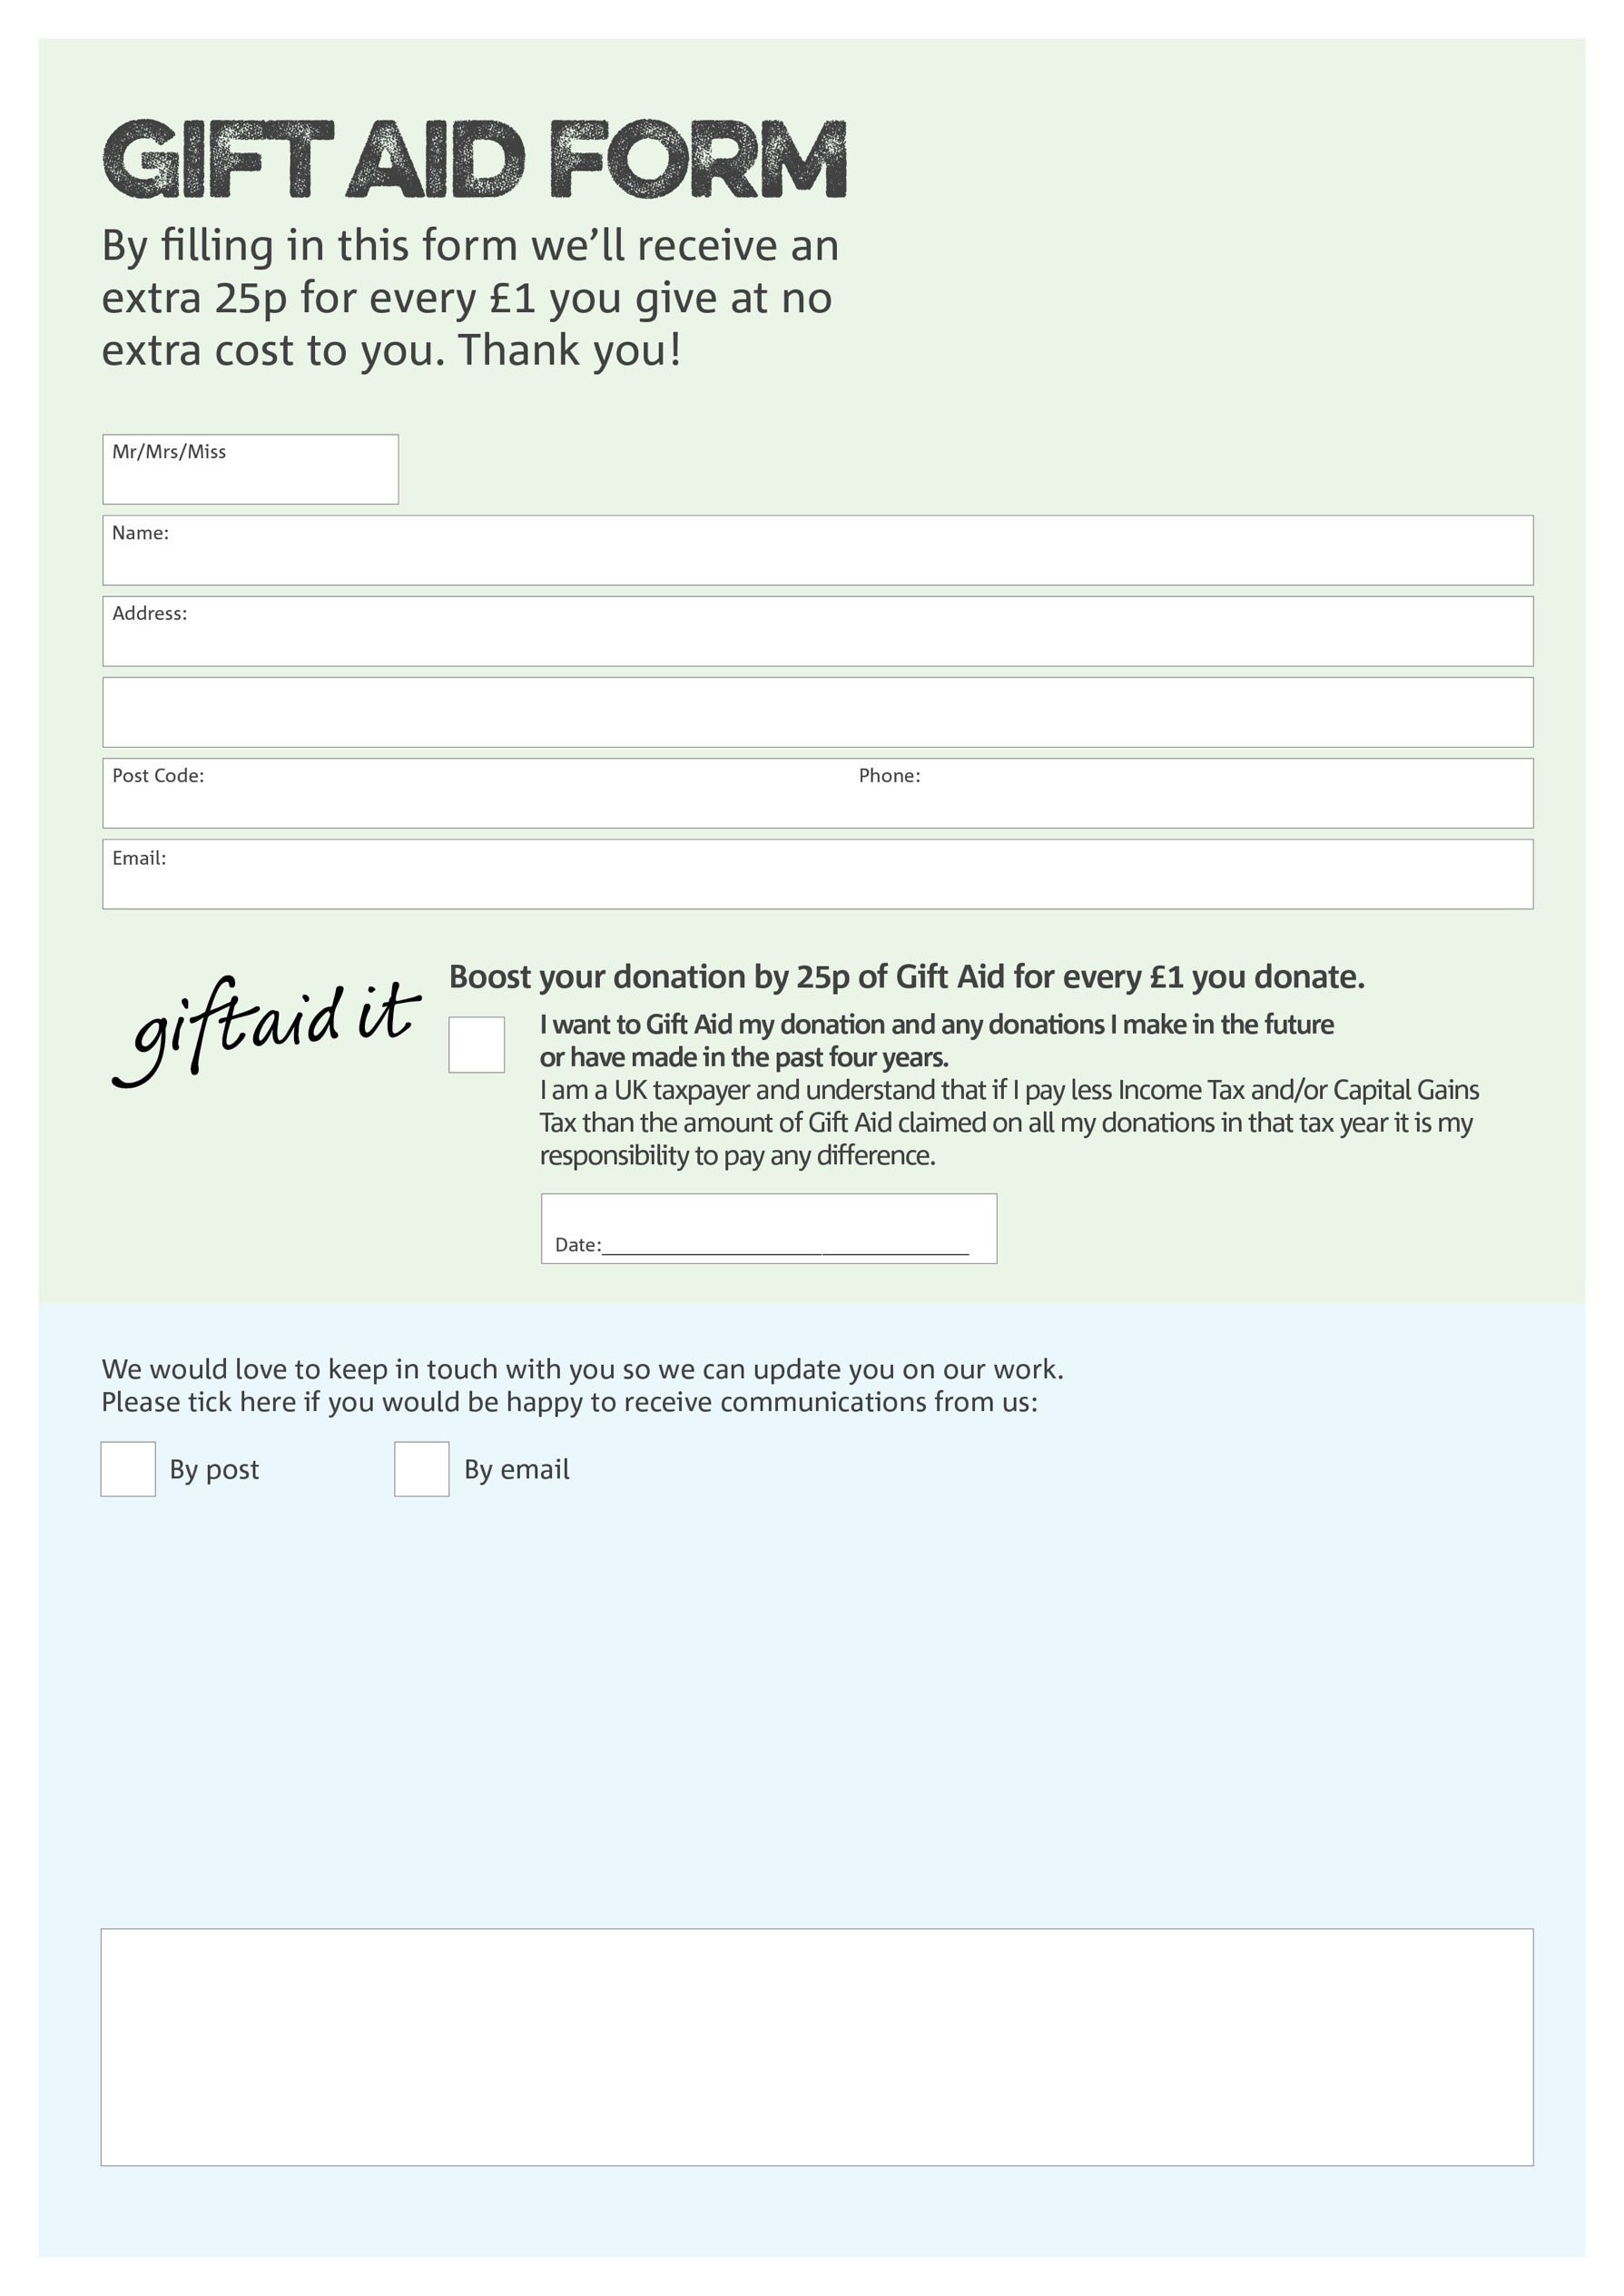


Data protection

Burngreave Foodbank is committed to protecting your privacy and will process your personal data in accordance with the Data Protection Act 1998. Burngreave Foodbank collects information to keep in touch with you and supply you with information relating to our work. Burngreave Foodbank will never sell or pass your details to anyone who isn’t directly working on our behalf.
Charity Number 1163895. Registered in England and Wales
We would love to know why you have chosen to donate to Burngreave Foodbank. If you would like to share your motivation let us know below:
You can change your preferences any time by contacting us on 07542 888671 or emailing us at
info@burngreave.foodbank.org.uk

